Assigning Pods to Nodes:
- By default k8 schedular takes care of assigning the Pods to nodes by spreading the pods across the nodes and not placing the pods on the nodes that have insufficient free resources.
- But sometimes we want to control on which node the pod lands, for example we only want a particular pod to land on a NODE having SSD device.

- Ways to assign PODs:

1. Node Selector:
- Works on the label selector model.
- Constraints pods on nodes with specific labels.
- We add labels to the Nodes and in the POD spec we specify the Node selector

- Add labels:
kubectl label nodes <node-name> <label-key>=<label-value>
kubectl label nodes Node1 disktype=ssd
- Then add Node selector to use this label.
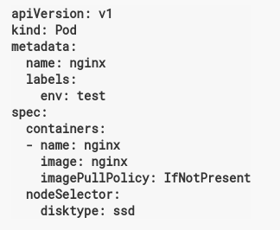

- If the labels on the Node change at run time, the PODs will still continue to work on the same Node.

2. Affinity and Anti Affinity :
a) Node Affinity:
- Similar to Node selector, where we constraint a POD on a node based on the labels on the Node.
- Additionally it provides:
1. More expressive language rather than just AND and exact match. We can use Operators Like ‘IN’ to select from different labels.
2. Provides both ‘Hard’ and ‘Soft’ preference.

Types of Node Affinity:
1. requiredDuringSchedulingIgnoredDuringExecution:
- This is a hard requirement.
- Rules must be met for the pod to be scheduled on a Node.
- Its like Node selector but with more expressive syntax.
- Ignored during execution means pod will still continue to run on the Node, even if the Node labels change at run time.
- For example – Run pod on nodes with SSD devices.

2. preferredDuringSchedulingIgnoredDuringExecution:
- This is soft requirement.
- The schedular will try to adhere with the preferences but there are not guarantees .
- Ignored during execution means pod will still continue to run on the Node, even if the Node labels change at run time
- Try to run Pod on nodes with SSDs, but if not possible, then allow it to run somewhere else.

- Expression Operator Supported are “In, NotIn. Exists, DoesNotExists. Gt, Lt”

POD Affinity and POD Anti Affinity:
- This constraints which nodes your pods can be scheduled based on the labels on the pods that are already running on the Node(rather than based on the labels on the node)
- Rule: “this pod should (or, in the case of anti-affinity, should not) run in an X if that X is already running one or more pods that meet rule Y”.
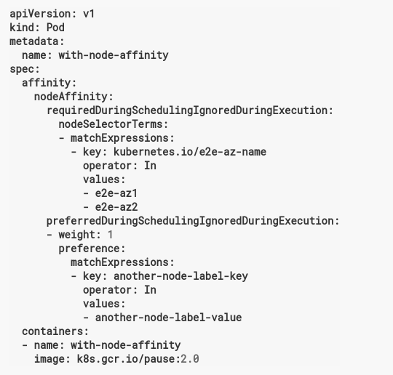
- Here, POD can be placed on the Node with key - “kubernetes.io/e2e-az-nam” and values (either of )
e2e-az1 or e2e-axz2.
- and in addition, among the nodes the full fill this criteria, node will label “another-node-label-key” and value “anothe-node-lable-value” should be preferred.

Taints and Tolerations:
https://kubernetes.io/docs/concepts/configuration/taint-and-toleration/

- Taints are opposite of Node affinity. Its helps the Nodes to repel the PODs.
- Taints and tolerations work together to ensure that pods are not scheduled on in appropriate nodes.
- Here, one or more taints are applied to a node to ensure that the nodes should not accept any pod that doesn’t tolerate that taint.

Adding a taint to a node:
kubectl taint nodes node1 key:value:NoSchedule.

- Now only those PODs that have a matching toleration can be scheduled to node1

Removing a taint from a Node:
kubectl taint nodes node1 key:NoSchedule-

- Toleration for a POD are specified in the podspec:

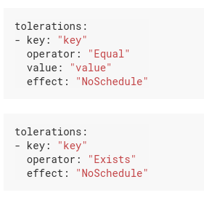

- Example of toleration on podspec:

